Dry Rice/Cous Cous/Lentils etc

Tip a bag of these dry items into a basin or tray. Use spoons, jugs etc to scoop and pour the rice etc. Allow hands and feet to explore them. Hide items in the basin.

Set challenges – find all the cars/dinosaurs. Find the red items. Find 5 things that are from the woods etc.

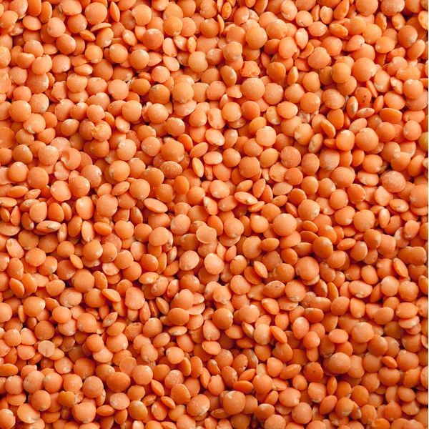
Cooked Pasta/noodles etc

Cook a bag of pasta or noodles. You can add food dye when cooking to vary colour. Allow hands and feet to explore them. Hide items in the basin.

Set challenges – find all the cars/dinosaurs. Find the red items. Find 5 things that are from the woods etc.

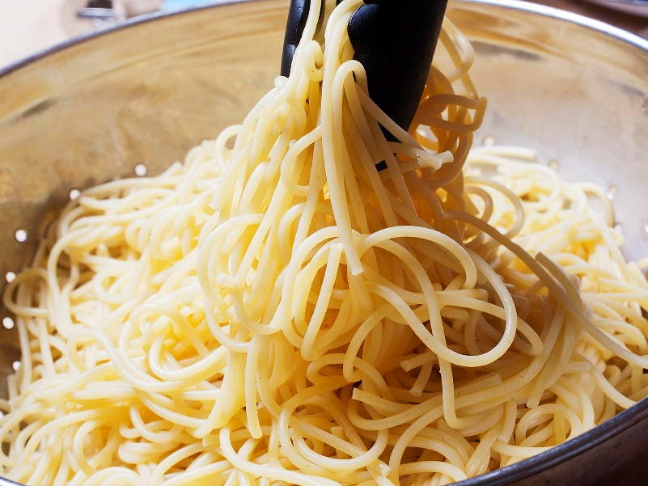

Jelly Play

Make up a bowl of jelly. At the liquid stage you can hide items in it. Use hands or feet to explore the jelly and find items in it. Describe the texture, colour, smell etc.

Set challenges – find all the cars/dinosaurs. Find the red items. Find 5 things that are from the kitchen etc.

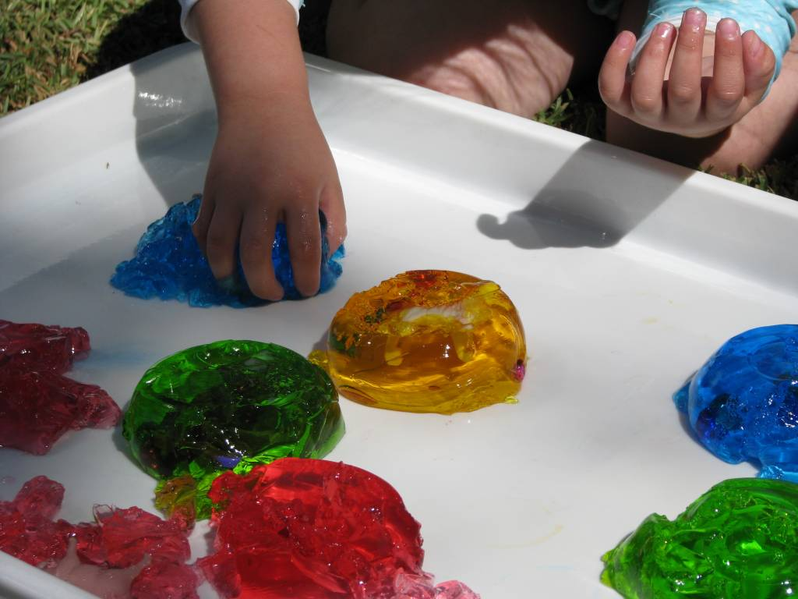
Gluck

Mix up cornflour and water. Make the consistency you want but allow for a real change between solid and liquid. You can add food colouring if you want. Ise spoons etc to scoop into jugs and pots and then pour it out. Describe the consistency, texture, temperature, colour etc.

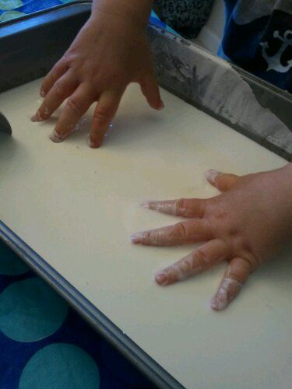
Flour and Veg Oil “Sand”

Mix flour and veg oil until you have a moist sand consistency. Use it as sand to build castles with buckets. Push around with hands and feet. Use toy trucks to make tracks. Describe what you and child are doing.

Set challenges to find hidden items. To knock down castles. To make hand prints.

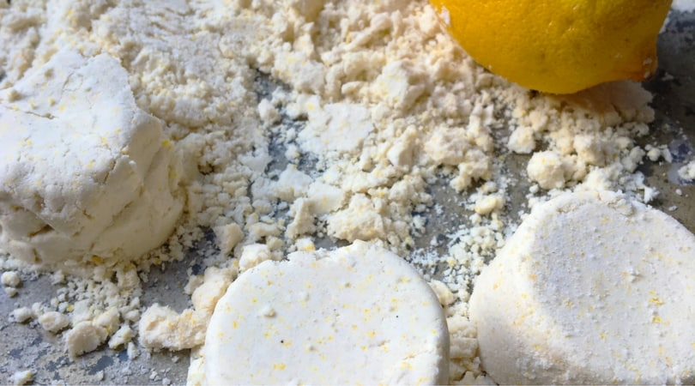
Water/Bubbles

Fill a bowl or basin with warm water and your usual bath bubbles. Froth up with a whisk. Add food colouring if you want to change colour. Hide items in the bubbles to find. Float and sink items in the water.

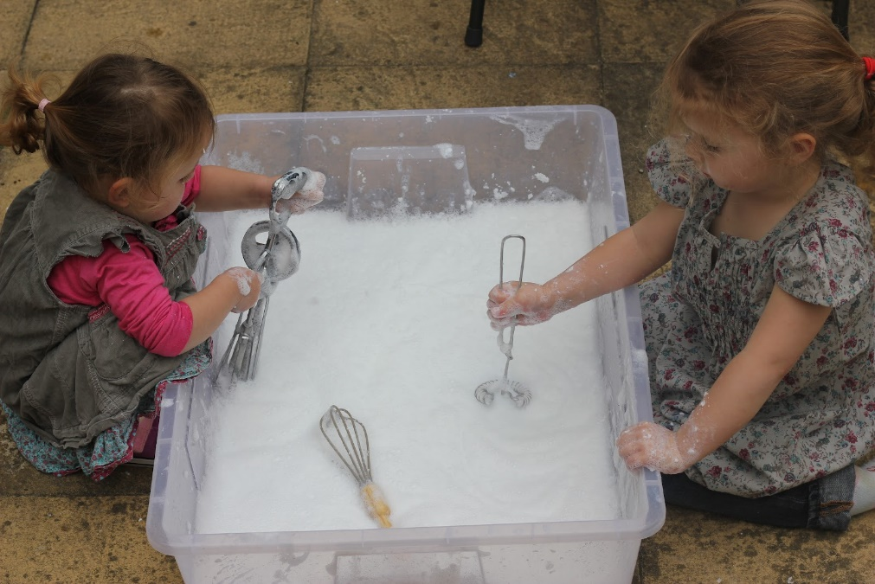

Messy Play Ideas

