1. | Why not visit the Holy Family School Facebook page and download our “Lap Tracker” to help you to track your steps or contact the Holy Family School class teacher for your copy.  Please return this sponsor card and funds raised by Thursday June 24th 2021.  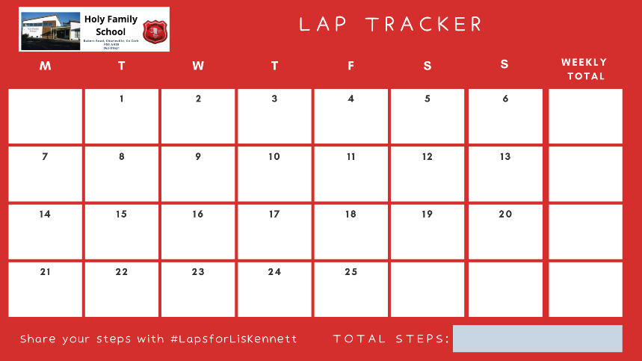
2.
3.
4.
5.
6.
7.
8.
9.
10.

